CAVCO SALES
Office: 620-767-7273 Mobile: 785-466-0189 Fax: 620-767-5303

Visit our Website & View All Our Machine Pictures: www.cavcosales.com

E-Mail Us: cavco@tctelco.net
Visit Our E-Bay Store At: http://stores.ebay.com/e-cavco

November 15, 2024

Pictures Are Available On-Line at www.cavcosales.com

We Are Distributors For The Following Manufacturers

Goodson Products - Regis Manufacturing – Winona Van Norman, Silver Seal - Kwik Way Boring Bar Repair Parts & Supplies – Van Norman/Peterson Flywheel Grinders And Boring Bars-CBN/PCD Tool Holders & ½” & 3/8” Diameter Inserts

Used Equipment List

‘

Crankshaft Equipment

CA2251 ABS Milling Mounted A Table Mounted Bench Mill Using R-8 Collets System Designed Around Drilling 3,275.00
Bench Mill & Milling Crankshafts When Using The Stewart Warner Balancer Without The Drill
Function. A Slide Way And Platform Makes The Weight Removal Process Extremely
Easy And Functional, 115v.

CA-HUBS Crankshaft Wheel We Have A Varity Of Used Crankshaft Grinding Wheel Hubs In Stock. Sorry But 150.00 – 250.00
Centers We Can’t Identify Many Of Them But We Can Measure And Send Pictures.

CA2265 Wheel Balancing Stand Precision Wheel Balancing Stand, 48” Diameter Capacity. 685.00
Comes With: New Paint and Adjustable Rails For Width.

Connecting Rod Equipment & Tooling

CA2377 Connecting Rod Goodson Propane Rod Heater Model RH-50. Requires Shop Air. 895.00
Heater-Propane Comes With: Fast And Hot Adjustable Flame. (Can work as fast as 15 seconds)

CA2304 Sunnen Precision Rod Sunnen Model AG-300. Long Finger. 1,145.00
Sizing Gauge Comes With: Gauge Mounting Bracket, Standard Points, Centralizer Rings,
Standard Tools And Metal Storage Box. Serial # 13964

CA2343 Sunnen Precision Rod Sunnen Model AG-300. 1,095.00
Sizing Gauge Comes With: Standard Points, Centralizer Rings, Wrist Pin Comparator Fixture,
Standard Tools And Metal Storage Box. Serial # 8063

CA2378 Sunnen Precision Rod Sunnen Model AG-300. 1,225.00
Sizing Gauge Comes With: Standard Points, Centralizer Rings, Wrist Pin Comparator Fixture,
Standard Tools And Metal Storage Box. Serial # 22375

CA2387 Rod Checking And KO Le Model C11. 695.00
Bending Fixture Comes With: Base, 3-Expanders, Adjusting Wrench, Straightness Checking Fixture
For Pistons And Wrist Pins And Rod Bending Bar.

CA2399 Rod Checking And KO Le Model C12. 895.00
Bending Fixture Comes With: Base, 3-Expanders, Adjusting Wrench, Straightness Checking Fixture
For Pistons And Wrist Pins And Rod Bending Bar.

CA2069 Rod & Pin Hone Sunnen 2-Speed Model LBA-650, 115v. 995.00
Comes With: Mounted On Wood Storage Cabinet, SL Mandrel Set (.720” – 1.200”),
Coolant Pump & Wrist Pin Vise.

CA2211 Horizontal Honing Sunnen Model MBB-1660, 115v. 2,450.00
Machine Comes With: Twin Torque Bar, 12-Speed Selections, Small Mandrel Fine Pressure
Adjustment And Adjustable Coolant Lines.

CA2277 Rod & Pin Hone Sunnen Floor Model LBB-1699, 115v. In Good Condition. 2,850.00 Comes With: Twin Torque Bar, 6-Speed Combinations And Spindle Feed Indicator.

CA2371 Rod & Pin Hone Sunnen Floor Model LBB-1699, 115v. In Great Condition. 3,450.00 Comes With: Twin Torque Bar, 6-Speed Combinations And Spindle Feed Indicator.

CA2321 Rod & Pin Hone Sunnen Floor Model LBB-1499, 115v 1,595.00
Comes With: Twin Torque Bars, Spindle Feed Indicator & 6-Speeds.

Cylinder Head Equipment & Tooling

CA2366 Serdi Light Valve Seat Cutting Machine, 115v. 5,950.00
Comes With: Spare Centering Unit, 8 Carbide Pilots, Assorted Tooling And
Vacuum Tester.

CA2393 Cylinder Head Dual A New DCM Head Clamping Fixture For Valve Guide & Seat Machines. 2,785.00
Axis Air-Float/Air Comes With: Air Float Base, Dual Axis Pneumatic Clamping Cylinders, Fast Mount
Clamping Fixture Head Mounting Clamps, All New Air Lines And Fittings, Air Operated Foot Valve.
A Very Nice Complete Fixture.

CA2394 Cylinder Head Dual A New DCM Head Clamping Fixture For Valve Guide & Seat Machines. 2,985.00
Axis Air-Float/Air Comes With: Air Float Base, Dual Axis Pneumatic Clamping Cylinders, Extremely
Clamping Fixture Fast Head Clamping Mounting System Designed For Repetitive Head Mounting,
All New Air Lines And Fittings, Air Operated Foot Valve. A Very Nice Complete Fixture.

CA2375 Valve Guide & Seat Winona Van Norman Model PH2000L, 230v, 3ph. 6,875.00
Machine Comes With: Extra Large Base, Quick Clamp Head Fixture, 3-Angle Seat Tooling,
Core Drill/Reamers, Valve Seat Pocket Cutter Set, Valve Seat Driver Set, Valve Guide
Driver Set, Drill Chuck, Leveling Pilots And Level, Valve Guide Spot Face Set, Auxiliary
Gear Set For Higher Speeds And New Paint.

CA2395 Twin Head Valve Guide Peterson Model TCM-25/2, 230v 3ph. 7,985.00
And Seat Machine Comes With: 2-Power Head, Large Air Float Fixture, Quick Clamp Head Mounting
Tooling, Standard Tooling Including: Seat Pocket Cutters, Valve Guide Installation Core Drill/Reamers, Valve Guide Top Cutters Set, Pilot Level, Leveling Pilots, Valve Seat
Driver Set, Valve Guide Driver Set, SGM Style 3-Angle Tool Kit And New Paint.

CA2396 Valve Guide And Peterson Model ASVA, 230v 3ph. 14,850.00
Tooling Seat Machine Comes With: 48” Large Air Float Fixture, Universal Head Mounting Tooling,
Standard Tooling Including: Seat Pocket Cutters, Valve Guide Installation Core Drill/Reamers, Valve Guide Top Cutters Set, Pilot Level, Leveling Pilots, Valve Seat
Driver Set With Pilots, Valve Guide Driver Set And SGM Style 3-Angle Seat Cutting Kit.

CA2386 Vacuum Tester Peterson/KI Vacuum Tester, 115v. 425.00
Comes With: Vacuum Gauge & 1 Test Pad.

CA2357 Centerless Valve IDL Centerless Grinder Model CG-82, 115v. 4,650.00
Refacer Comes With: New Stones, Optional Large Stem Butt Grinding Attachment And New
Paint.

CA2390 Valve Refacer And Sioux Model 2001 With Sioux Storage Cabinet, 115v. 2,850.00
Storage Cabinet Comes With: Variable Speed Chuck, But Grinding Chamfer Tool And Sioux
Refacer/Storage Cabinet.

CA1788 Valve Seat Grinding KO Lee Model P302BB, 115v. 745.00
Set Comes With: 1-Stone Holders, Electric Driver, Stone Dresser, 6-Collapsing Pilots,
Metal Storage Box And 25 Various Grinding Stones.

CA2167 Valve Seat Grinding Black & Decker, 115v. 525.00
Set Comes With: 2-Stone Holders, Electric Driver, Stone Dresser, 4-Groove Top Pilots,
Pilot Installer/Removal Tool, Metal Storage Box And Various Grinding Stones.

CA2174 Valve Seat Grinding Sioux Model 1725E, 115v. Hex Drive. 875.00
Set Comes With: Angle Electric Driver, A Good Selection Of Stones & Pilots, 2 Wheel
Holders, Stone Dresser And Metal Storage Box.

CA2355 Valve Seat Wet Sioux Wet Seat Grinding Bench, Model 1650, 115v. 2,650.00
Grinding Bench Comes With: Overhead Remote Exhaust Air Driver, Solvent Pump, Dual Cylinder
Head Holders & Air And Electrical Outlets.

CA2362 Valve Seat Wet Sioux Wet Seat Grinding Bench, 115v, Model 1650. 2,875.00
Grinding Bench Comes With: Overhead Remote Exhaust Air Driver, Solvent Pump, Dual Cylinder
Head Holders & Air And Electrical Outlets.

CA2072 Heated Cylinder Head Manufactured By Donelly Engineering. Uses Heated Water Circulated Through The 1,250.00
Pressure Tester Head To Perform The Test Heated, 220v, 3ph. 43” Capacity.

CA2323 Cylinder Head Master Tool/Peterson Machine Tool Model PT-38. 3,850.00
Pressure Tester Comes With: Steel Pressure Plates, Universal Block Off Tooling And Standard Tools.

CA2325 Submerged Cylinder Axe Model UP-1437. 4,850.00
Head Pressure Tester Comes With: 20-Universal Plate, New Paint And All Standard Tooling.

CA2341 Submerged Cylinder Axe Model UP-1437. 5,295.00
Head Pressure Tester Comes With: 20-Universal Plate, New Paint And All Standard Tooling. Very Nice Machine

CA2351 Cylinder Head Master Tool/Peterson Machine Tool Model PT-48. 5,595.00
Pressure Tester Comes With: Steel Pressure Plates, Universal Block Off Tooling, Complete Set Of
Segmented Diesel Head Testing Plates & Block Testing Tooling. And Standard Tools.

CA2188 Cylinder Head Porting/ Kwik Way Manufactured These Rollover Stands. Dual Head Capacity. 575.00
Rollover Fixture

CA2320 Adjustable Head A Heavy Duty Head Mounting Fixture. 845.00
Clamping Fixture Extremely Heavy Duty Fixture With X & Y Axis Adjustability.

CA2356 Valve Refacer Cabinet Sioux Cabinet. . 355.00

Surfacing Equipment

CA2068 Dry Surface Grinder Van Norman Model 555, 230v, 3ph. 550.00
Comes With: 10” Stone.

CA2367 Flywheel Grinder DCM Model 7000, 230v, 3ph. 6,370.00
Comes With: Standard Tooling, 6” CBN Wheel, Grinding Coolant, Corner Cutting
Attachment & New Coolant Pump. (NOTE: The Auto Feed System Has Been Disabled.)

CA2380 Dry Surface Grinder Peterson Dry Grinder Model 50F, 240v, 1ph. 2,350.00
Comes With: Dresser Assembly, New Grinding Wheel, Dust Collector And New
Paint.

CA2391 Dry Surface Grinder Van Norman Model 557, 230v, 3ph. 925.00 Comes With: Usable Stone And Stone Dressing Fixture.

Block Boring & Honing Equipment

CA2372 Berco Line Boring Berco Model BC-5, 230v, 3ph. 25,500.00
Machine Comes With: 25, 30, 40, 50, 60mm Bars With Correct Bearings, Thrust Cutter,
An Assortment of Tooling, 2-Sets Parallels, New T-Bolts, Snap Gauge Set
And New Paint.

CA2374 Rottler Boring Fixture Rottler Model F2B, 230v, 3ph. 9,950.00
Comes With: Standard Production Boring Head & Tooling, 45 Deg Cradle & Lift Bar,
30/60 Degree Cradle. In Very Nice Condition.

CA2397 Engine Boring Machine Berco Model AC-750A, 230v, 3ph. 23,850.00
Comes With: 4-Different Boring Spindles, 3-Different Boring Heads, Tool Setting
Fixture, New Way Bellows, Universal Mains Bore V-Block Set-Up Fixture, Universal
Block Clamping Fixture, Block Parallels, Machine Level, Drill Chuck, Small Diameter
Bridgeport Style Boring Head And Miscellaneous Tooling.

CA2382 Large Portable Boring Van Norman Model 999, 115v. With 30” Of Spindle Travel. 5,790.00
Bar Comes With: Complete Tool Kit, New Paint & Bar Clamping Tooling.
CA2392 Portable Boring Bar Storm Vulcan Model 250v, 115v. 1,595.00
Comes With: Complete Tool Kit And Deck Clamp Tooling.

CA2364 Engine Boring Stand Axe Model BS-32. Allows For Block Placement Using Portable Boring Bars. 495.00
Comes With: Rotating Engine Stand Type head, Mains Bar And Catch Tray.

CA2400 New Aftermarket Line 10RY-1800 2,350.00 Hone Mandrels 10RY-2100 2,450.00
10RY-2400 2,550.00 10RY-2700 2,650.00
10RY-3000 2,750.00
15RY-4000 3,795.00 15RY-5000 4,295.00

CA2359 Midget Portable Sunnen Model SN-75 Hone Head For A Drill. 365.00
Cylinder Hone

CA2368 Air Assisted Cylinder Peterson/Kansas Instruments Model HC1, 115v. 5,290.00
Hone Comes With: Standard AN Sunnen Hone Head, Air Assist Cylinder, Coolant Pump,
A Selection Of Stones, Universal Clamp Tooling And Oil Filter.

CA2398 Power-Stroke Cylinder Sunnen Model CV-616, 230v, 3ph. 18,950.00
Hone, Comes With: Standard CK-3000 Hone Head (3.0-5.0”) Capacity, Several CK-3035 &
3045 Stone Holders, CK-3030 Diamond Holders With P28-DM35 Roughing Diamonds,
Stone Inserting Fixture, Bore Diameter Setting Device, New Oil Filters.

Cleaning Equipment

CA2358 Small Parts Tumbler Sioux Model 710, 115v. 1,325.00
Comes With: New Gears, New Paint And In Good Condition And A Full Load
Tumbling Of Media.

CD2293 Glass Bead Cabinet A Good Used Trin-Mac Glass Bead Cabinet, Model 3, 115v. 24” x 36” Capacity. 925.00
Comes With: New 25CFM Gun & Carbide Nozzle, New Dust Collection Hose, New
Window Glass And Door Safety Switch.

CA2219 Glass Bead Cabinet A Twin Feed Cyclonic Bead Reclaimer For Glass Bead Cabinets. Allows for Single Or On Hold
Reclaimer Unit Dual Gun Operation. 1/2HP, 120V Blower Motor. Intake Size is 5” and Discharge Size
Is 4”. Can Be Used With A Dust Bag On The Discharge.

CA2339 Thermal Cleaning Peterson/Kansas Instrument Thermal Cleaning Oven Model BK-17, 115v 7,800.00
Oven Comes With: New Paint, Standard Loading Cart, New Temperature
Controller, Over Temperature Control System. Tested And Ready For Service.

CA2354 Thermal Cleaning Peterson/Kansas Instrument Thermal Cleaning Oven Model BK-17, 115v 6,900.00
Oven Comes With: 12’ Exhaust Stack, Standard Loading Cart, New Temperature
Controller, Over Temperature Control System. Tested And Ready For Service.

CA2298 BK-17 Oven Transfer This Allows A Hot Load To Be Moved To The Next Location Without Waiting Until The 685.00
Cart Load Is Totally Cool.

CA2253 7.5 HP Replacement WEG 7.5HP Pump/Motor Assembly, 230v, 3ph. 695.00
Spray Washer Pump Comes With: 14” Stem Length, Complete Pump & Impeller Assembly. Tested And
Ready To Work.

CA2308 7.5 HP Replacement Gusher 7.5HP Pump/Motor Assembly, 230v, 3ph. 725.00
Spray Washer Pump Comes With: 15.5” Stem Length, Complete Pump & Impeller Assembly. Tested And
Ready To Work.

CS1026 Solvent Tank Clean-Master, Large Solvent Parts Washing Tank, Model 90, 45 Gallon Capacity, 115v. On Hold Comes With: Parts Cleaning Shelf and Castors For easy Positioning. Nice Looking Piece.

CA2114 Solvent Tank Free Standing Solvent Parts Washer, 115v. 165.00 Comes With: Decent Small Unit.

CO1663 Shot Tumbler Geoff Belt Type, 230v, 3ph. 950.00

Miscellaneous

CA2220 Vertical/Horizontal Grizzly Model G3617, 110v or 220v, 1ph. 4,650.00
Milling Machine Comes With: Separate Motors For Vertical/Horizontal Operation, Mill Vise, X-Axis
Power Feed, T-Nut Clamp Kit, Collet Set And Standard Wrenches.

CA2306 Smithy Combination Smithy Model Granite 1340, 115v. In Very Nice Condition. 4,650.00
Mill/Lathe/Drill Comes With: A Good Assortment Of Tooling. Uses R-8 Collets.

CA2327 9 x 49 Knee Mill Supermax Base With Bridgeport Head, Model YCS-16VS, 230v, 3ph. 4,495.00
Comes With: Variable Speed, 9” x 49” Mill Table, X-Axis Power Feed.

CA2261 Piston Knurler Perfect Circle Model “Knurlizer”. 865.00
Comes With: Preset Adjustable Stops And Regulated Pneumatic Control.

CA2360 Hardness Tester Enco Model EXP-NRS. 525.00

CA2228 25 Ton Hydraulic Nugier Manual H-Frame Press Model H25-7. 975.00
H-Frame Press Comes With: Cable Lift System, Press Plates And New Paint.

CA2274 15 Ton Hydraulic 15Ton Manual H-Frame Press, Bottle Jack Style 465.00 H-Frame Press Comes With: Some Tooling.

CA2040 Combination Brake Ammco Model 4000, 115v 1,575.00
Drum & Rotor Lathe Comes With: Standard 1” Brake Tooling Package, 9/16” Small Bar Kit, Spare Rotor
Inserts, Large Work/Storage Bench With Tool Board.

CA1029 5HP Air Compressor Kellogg American, 2-Stage, 230v, 3ph. 675.00
Comes With: Completely Tested, New Magnetic Starter & 80 Gallon Tank.

CA2231 Tig Welder Miller Dial-Arc HE, 220v, 1ph. 1,075.00
Comes With: H.D. Wheeled Cart A Good Selection Of Welding Rods And A Large Gas
Bottle

CA2237 400 Amp Mig Welder Ideal-Arc 235, 230v, 3ph. 945.00
Comes With: Heavy Duty Cart, Small Gas Bottle W/ Regulators. 100% Duty Cycle at 400A
80% Duty Cycle At 435A.

We Have A Good Stock Of Used Sunnen Mandrels! Call For Pricing & Availability.

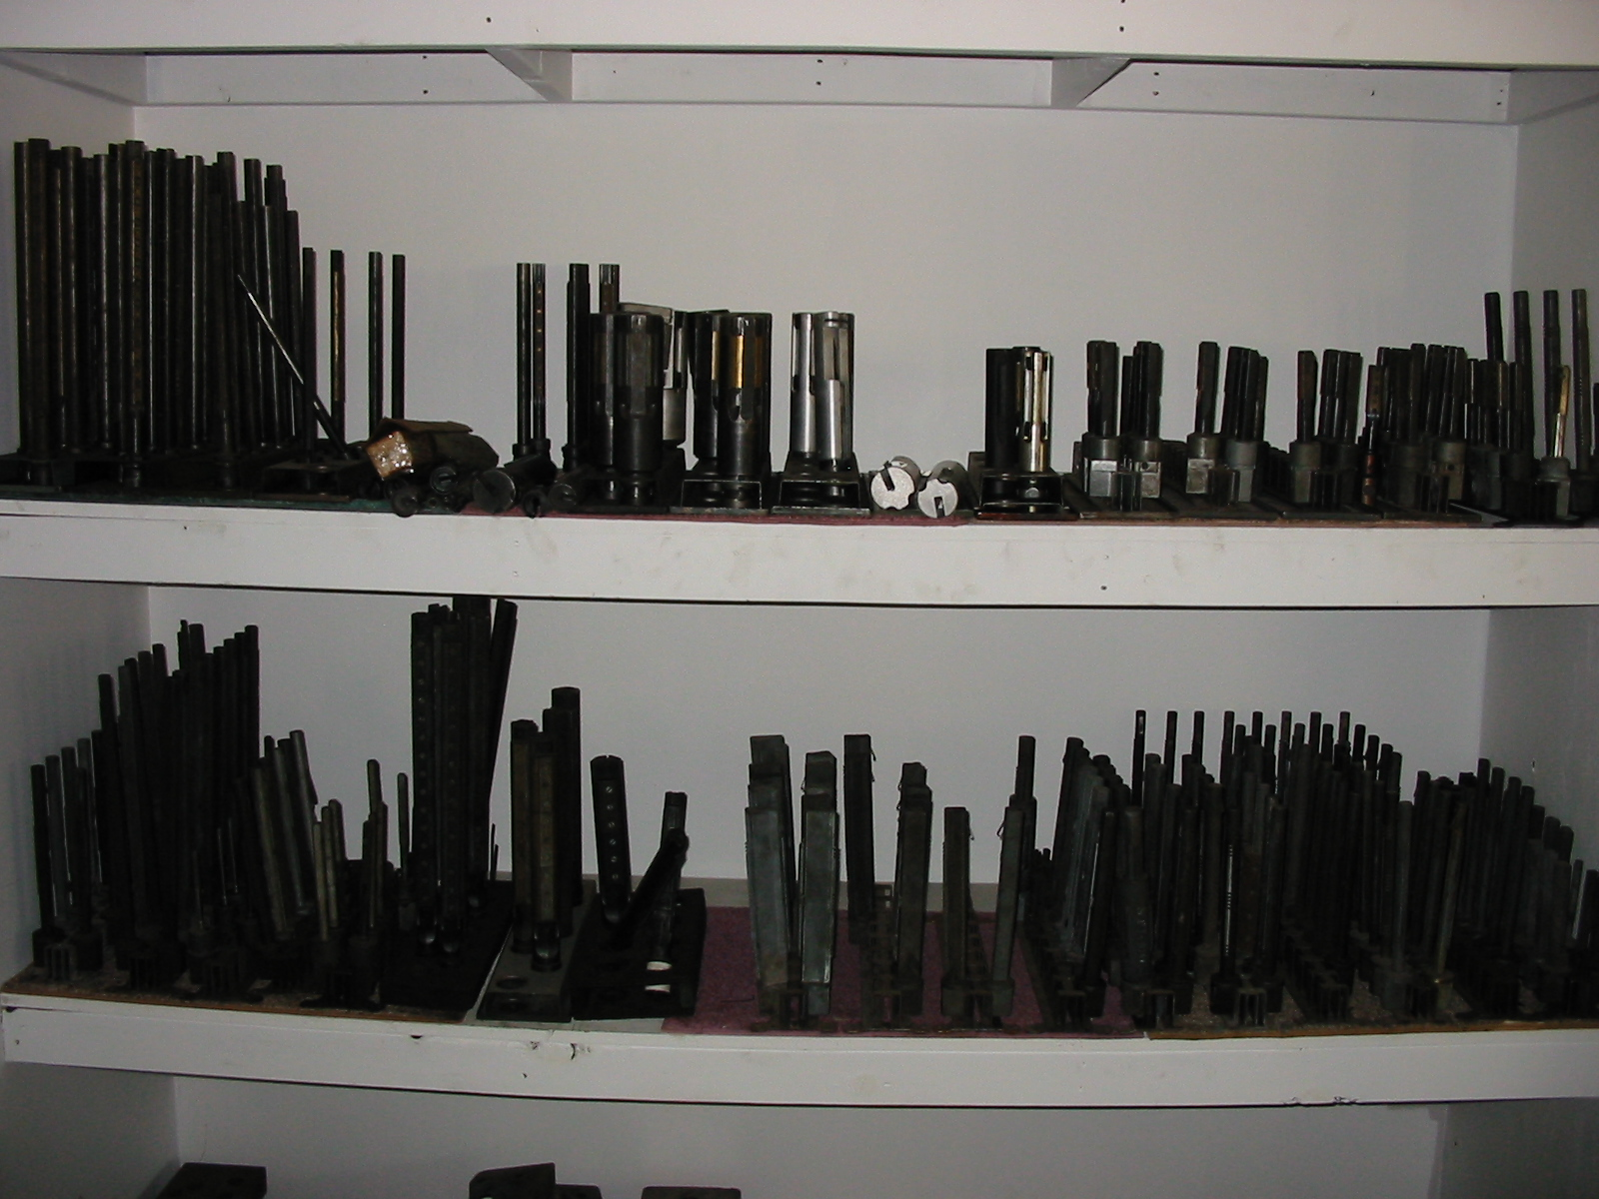

All Of Us Here At Cavco Sales Appreciate Your Business Dan – Cindy – Cameron – Caleb & Jeff

